WHILE statement is a command that functions to perform the repetition process, where repetition will continue if certain conditions are met. If the amount of repetition is not known so the FOR statement cannot be used, so it must use WHILE or DO-WHILE statements. The form of the WHILE statement is:

1. Create a program to display the series (up to the nth term): 1 3 9 27 ......
2. Create a program that initially asks for width and height data, then draws a drawing

rectangle based on width and height data. Suppose width = 10 and height = 4,

then the resulting image is:

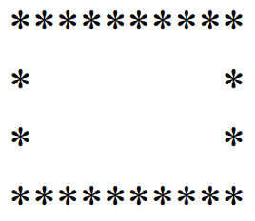

4. Buat program untuk menghitung:

1. a^b
2. n!
3. menghitung rata-rata